Name:  Teacher : | ____________________________________  ______________________ |  | Date:_________
 | Year 7  / 38  Skills test 1  Full working out MUST be shown to get full marks for each question.
Total Time: | 30 minutes
Weighting: | 5%
Equipment: | To be provided by the student: Pen, pencil, ruler only.

- Circle either True or false for each question. (8 marks)
- 7 + 6 = 6+ 7 True / False
- 14 – 7 = 7 – 14 True / False
- If I want to multiply 4x6x8x3 I can multiply the numbers in any order. True / False
- 24 ÷ 3 gives the same answer as 3÷24. True / False
- If I want to solve 2 – 6 ÷ 3 + 4 ÷ 2 then the first step is 4 x 2. True / False
- The second step I will do when solving 3 - (4 + 6) ÷ 2 is 10 divide by 2. True / False
- In 34 + 6 -2, it is okay to do 6-2 first. True / False
- If multiplying 26 x 4, I can add 20 x 4 and 6x4 together to get the answer. True / False

- Draw a line from each of the following decimals to where they belong on the number line. (8 marks)

0.4 2.01 0.08 0.15 2.10 1.06 1.2 2.0

- Round the following numbers. (4 marks)
- 13.454 to 2 decimal places

- 2.83 to 1 decimal place

- 19.119 to 2 decimal places

- 12.99 to 1 decimal place

- Mistakes happen. Here are 4 maths sums that contain mistakes. (8 marks)
- Show the correct working and give the correct answer.

- Explain how the mistake was made

$$157$$
$$+ 44$$
$$191$$

- Show the correct working and give the correct answer.

- Explain how the mistake was made

$$275$$
$$- 16$$
$$115$$

- Show the correct working for 1 of these and give the correct answer.

- Explain how the mistake was made

Do only 1 of these 3 multiplications
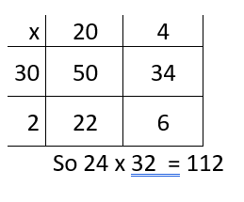
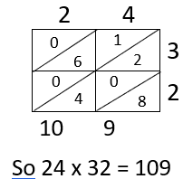
$$24$$
$$× 32$$
$$48$$
$$72$$
$$120$$

or
or

- Show the correct working and give the correct answer.

- Explain how the mistake was made

- Below are 4 examples where the BIMDAS rules have not been followed. (8 marks)
- Underline the mistake.
- Give the correct answer.
$$iii) 24÷4 ×2$$
$$=24÷8$$
$$=3$$

$$ii) (7-2+ 3)×2$$
$$=\left(7-6\right) × 2$$
$$=1 ×2$$
$=2$

$$i) 24-2 × 3$$
$$=22× 3$$
$$=66$$

$$iv) 4 ×3-(18÷6-2)$$
$$= 4 ×3-(3-2)$$
$$=4 ×3-1$$
$$=4 ×2$$
$$=8$$

- In your own words, explain why we need to follow the rules of BIMDAS. (2 marks)

